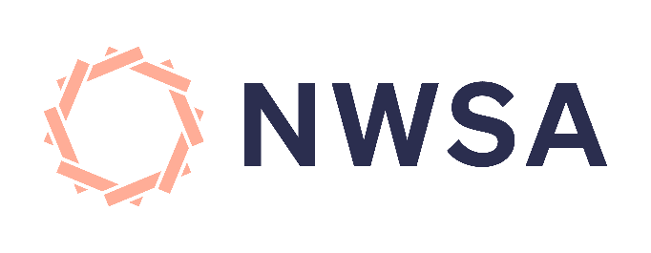

Media Release
Thursday, 22nd of December 2022
11 women have lost their lives in the last three weeks. The NWSA are reflecting on what we need to see urgently from all governments in 2023.
We commend the Albanese Government for their significant and essential investment in primary Prevention; cultural and structural change must go hand in hand to create a safer Australia for everyone who makes their home here.
We can’t ignore the National Emergency unfolding in front of us. 50 women have died this year and our frontline services are working at maximum capacity. We know that there is a rise of family, domestic and sexual violence in any holiday period- in some states upwards of 26.5%. Statistically, this means that before the end of 2022 more women will likely be murdered by a former or intimate partner or other family member.
Calls that go unanswered and fully booked services are not merely service level inconveniences, they reflect a risk to someone’s life and their ability to manage their safety.
Women and children must be able to stay safe, they must have safety options available.
We need to innovate solutions between the federal and state governments to ensure our frontline services are fully supported to care for every person who walks through their doors this holiday period and every other day.

